# NEWS FLASH

**PUPIL PACK MAY 18-22**

## TIMETABLE FOR THE WEEK

**\*\*\***

**WORKSHEETS FOR THE WEEK**

**\*\*\***

**THIS WEEK’S ACTIVITIES**

|  |  |  |  |  |
| --- | --- | --- | --- | --- |
| **MONDAY** | **TUESDAY** | **WEDNESDAY** | **THURSDAY** | **FRIDAY** |
| **MENTAL MATHS CHALLENGE** | **MENTAL MATHS CHALLENGE** | **MENTAL MATHS CHALLENGE** | **MENTAL MATHS CHALLENGE** | **MENTAL MATHS CHALLENGE** |
| **DAILY QUIZ** | **DAILY QUIZ** | **DAILY QUIZ** | **DAILY QUIZ** | **DAILY QUIZ** |
| **MAGIC SQUARE PUZZLE** | **MAGIC SQUARE PUZZLE** | **MAGIC SQUARE PUZZLE** | **MAGIC SQUARE PUZZLE** | **MAGIC SQUARE PUZZLE** |
| **UNJUMBLE THIS MESS** | **WRITER’S DEN**  **STORY TIME** | **YOU HAVE GOT TO TRY ...** | **ALPHABET ANIMALS** | **POETRY:**  **MY SPORT** |
| **QUESTION TIME** | **SO MANY MISTAKES!** | **CLOZE TEST TIME** | **MATHS STORY** | **WORD WORKOUT** |

**Answer Sheet for your daily**

**MENTAL MATHS**

**10 mental maths questions read aloud. You write down the answers as quickly (and correctly) as you can! If we are going too fast for you, just play it again, and again, until you get all completed. We'll reveal the answers tomorrow, before we begin the next one.**

**NAME: DATE: SCORE:**

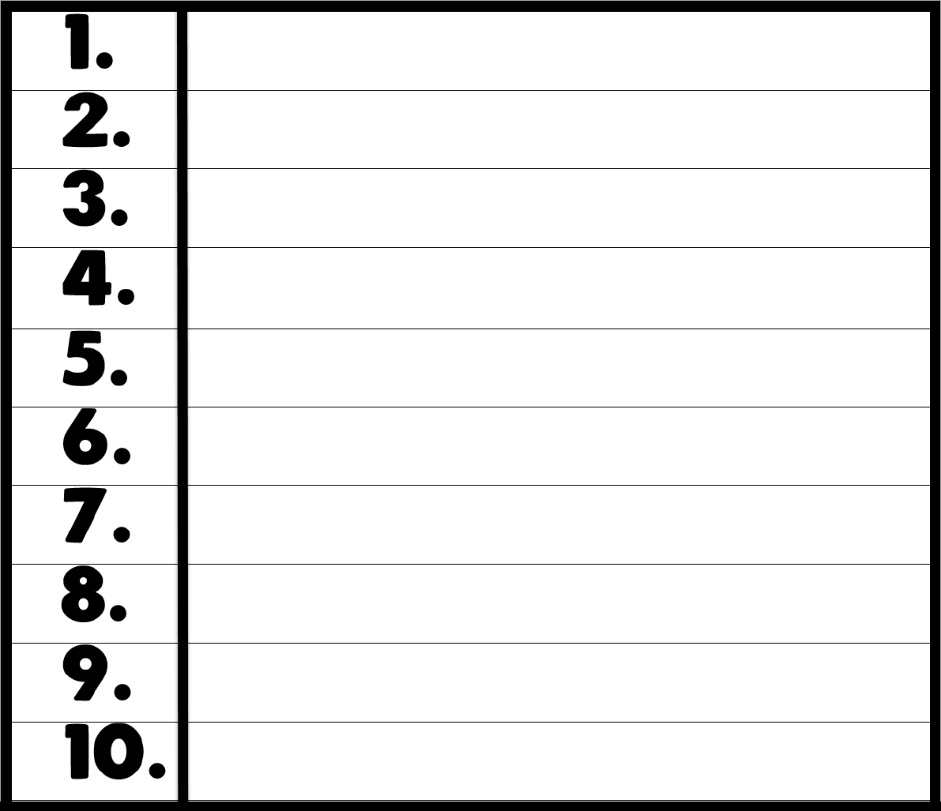

**Answer Sheet for your**

**DAILY QUIZ**

**Right, before anyone asks you to do anything, be ready to shout: IN TWO MINUTES!**

**As that's how long it will take you to complete this, we're thinking.**

**OK, enough of the intro, we want answers ... NOW!**

**NAME: DATE: SCORE:**



**Procedure Writing Activity: Monday, May 18**



**UNJUMBLE THIS MESS!**

This week's procedure writing activity needs you to sort out the mess below. Each sentence contains the correct words but we need you to put them in the correct order or sequence. Once you do, your sentences should then make perfect sense.

sunny day. Monday very was a

programme. On I my watched favourite Tuesday

like walk. Every I to for go a Wednesday

forgot Thursday, school. I on I there was no up When woke

is week. Friday favourite of day the my

I to go training football Saturday. on

all Mass Sunday. to on a go We

**Comprehension Activity: Monday, May 18**

**QUESTION TIME**

**How well have you read this month's paper? Here, in Question Time, as well as testing your memory and retention skills, we also test your imagination and creative skills. We base this activity on the news pages, page 4, 5, 6 and 14.**

1. In which country was Florence Nightingale born?
2. Crimea is a peninsula on the coast of which sea?
3. What did Florence call the military hospital in Scutari, in Turkey?
4. What disease did Florence contract at the hospital in Scutari?
5. Which famous engineer designed Renkioi Hospital in Turkey?
6. What was the brooch that Queen Victoria gave to Florence called?
7. In what year was Florence awarded the Royal Red Cross?
8. Who was America’s first trained nurse?
9. On what date is International Nurses Day celebrated?
10. Florence Nightingale was known as ‘The of the Crimea’.

**Daily Maths Activity -- Monday, May 18**

**MAGIC SQUARES**

What is a Magic Square?

In a Magic Square, every row, column and diagonal all add up to make the same total.

In this yellow magic square, the sum is 15. That means each row, column and diagonal all add up to make 15.

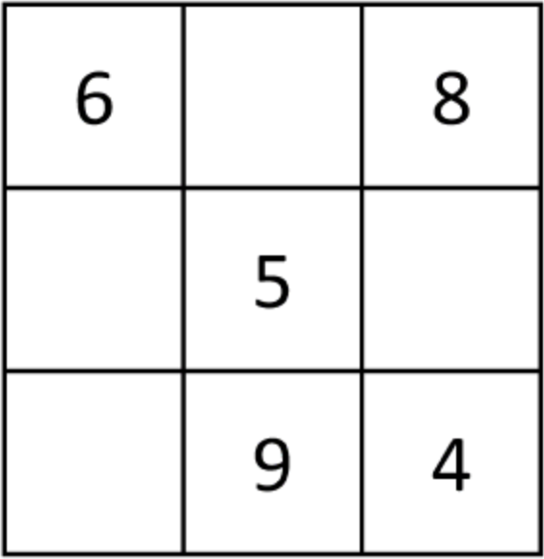

In this yellow magic square, the sum is 18. That means each row, column and diagonal all add up to make 18.

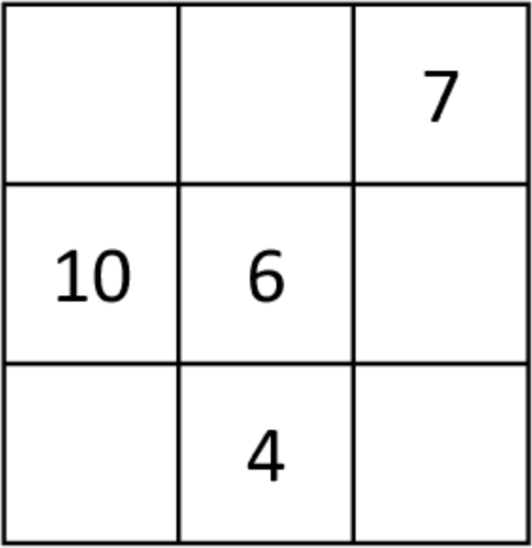

**Narrative Writing Activity: Tuesday, May 19**



**WRITER'S DEN**

Tuesday’s Writing Activity invites you to write a short story based on the title and image below:

## OH NO! NOT AGAIN



**Grammar Activity: Tuesday, May 19**

**SO MANY MISTAKES!**

**This week’s grammar activity is based on a great story about a bot who discovers a valuable diamond a number of years ago. Read through the article and see if you can spot the 10 spelling mistakes.**

**do, in your best handwriting, fill in the two grids below.**

**MEXICO**

**10 SPELLING MISTAKES**



Mexico is one of the world’s largest oil producers and exports oil to the United States of America (USA).

The country has a huge ammount of silver, copper, lead and zinc. Many US-owned companies have big factorys in Mexico where wages and taxes are lower.

Their producks are then sold back across the boarder in the USA.

Many poor Mexicans also cross over to the USA looking for better payed jobs. Mexico City with a popalation of over 21 millon is the 6th largest sity in the world. It is bilt on the site of the Aztec city of Tenochtitlán.

The city hosted the Olympic Games in 1968. It is built on a lake and has sunk almost 10m in the last 60 years.

Mexico attracks tourists from all over the world. It has beautiful beaches, over 30 UNESCO Heritage sites, wonderful old towns, and very freindly people.

**Daily Maths Activity -- Tuesday, May 19**

**MAGIC SQUARES**

What is a Magic Square?

In a Magic Square, every row, column and diagonal all add up to make the same total.

In this yellow magic square, the sum is 30. That means each row, column and diagonal all add up to make 30.

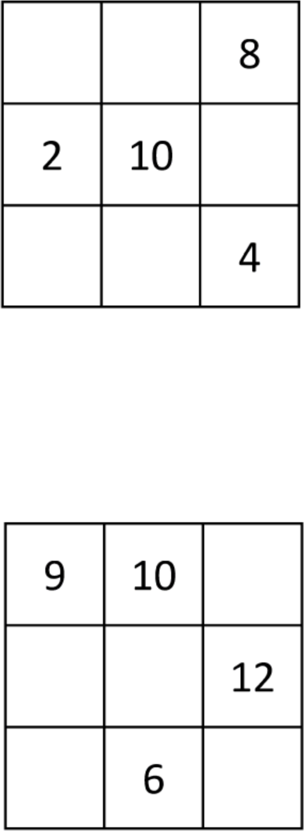In this yellow magic square, the sum is 24. That means each row, column and diagonal all add up to make 24.

**Persuasive Writing Activity: Wednesday, May 20**

**YOU HAVE GOT TO TRY ...**

This month's writing activity needs you to convince the reader to either try, taste, play or do something you LOVE to do yourself. From reading, to movies, to playing sport, to cooking something, it doesn't matter what you suggest as long as you remember -- the whole point of this exercise is to persuade others to do it too.



**Cloze Test Activity: Wednesday, May 20**

**FILL IN THE BLANKS**

**This week’s cloze test is all about ants! We’ve made it a bit trickier by taking out 8 words. This is called a cloze test. Read through the words first and make sure you understand them. Then, read through the article. Make sure you think about the best place to put a word, not the first place. Careful as you go, as some words may fit in a few places, while other words will only suit one place.**

**THE BLACK MAMBA**

**excellent hollow mouths fastest inject bellies prey fangs**

I’m a black mamba, the largest and most venomous snake in all of Africa. I’m also one of the (1) snakes in the whole world – I can slither along at up to 20km/h and I can climb trees very quickly.

I’m deadly, but I’m never black. Black mambas have slender olive-brown to grey backs covered in smooth scales and our (2) are light grey. So, where does the ‘black mamba’ name come from? We get our name from the colour of the inside of our (3), and if you ever get close enough to see that … well it could very well be the end of you.

I am a predator and I hunt warm-blooded (4) such as bushbabies, bats, rodents, and birds. I hunt during the day and I have (5) eyesight. I have two, short (6) at the front of my mouth which I use to bite my victim. Next, I (7) my venom into them which paralyses them in a short time, and then I can eat my tasty meal. Acids in my stomach digest the prey in eight to ten hours.

At night I sleep in a (8) log – other black mambas may live in a hole in the ground, a rock crevice or even a termite nest. I have very few predators apart from birds of prey, but young black mambas are often eaten by other snakes.

**Daily Maths Activity -- Wednesday, May 20**

**MAGIC SQUARES**

What is a Magic Square?

In a Magic Square, every row, column and diagonal all add up to make the same total.

In this yellow magic square, the sum is 21. That means each row, column and diagonal all add up to make 21.

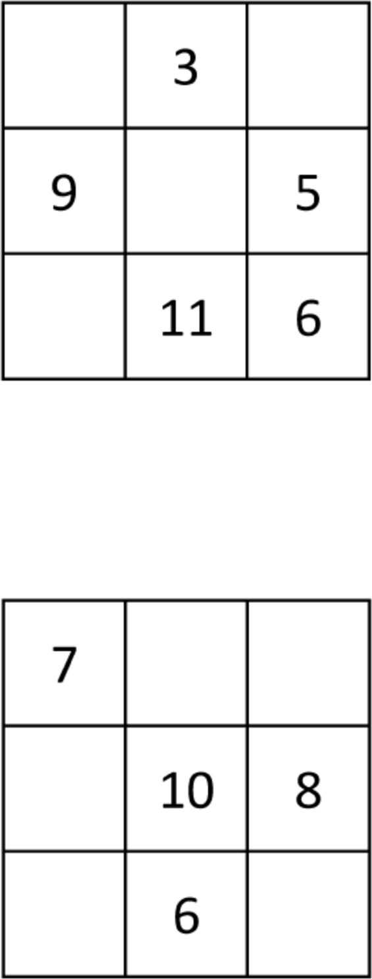In this yellow magic square, the sum is 30. That means each row, column and diagonal all add up to make 30.

**Report Writing Activity: Thursday, May 21**

**ALPHABET ANIMALS**

For this Report Writing activity, we give you children are given a letter and you must write a short report (or a series of facts) on an animal beginning with it.



C

This week's letter is ...

**1.**

**2.**

**3.**

**4.**

**5.**

**Maths Activity: Thursday, May 21**

**MATHS STORY**

**Read this week's Maths Story and see if you can solve the problems below. This is not a quick-fire maths activity, so take your time, have a working-out sheet beside you and adopt the RUDES approach:**

1. READ carefully
2. UNDERLINE (key words)
3. DRAW a diagram if you need to. This often helps.
4. ESTIMATE your answer
5. SOLVE the problem.

**RED PANDA ALERT!**

A red panda called Amber which escaped from Belfast Zoo was found the following day. She was discovered safe and sound in Newtownabbey, about a kilometre away from her enclosure.

Zoo manager, Alyn Cairns thanked all involved in the search for the missing red panda. ‘We received several calls from local residents who reported sightings which helped the search team to track its location,’ he said. Mr Cairns added that staff had discovered ‘a power fault’ in an electric fence shortly after Amber went missing.

Amber and her sister Autumn were born at Belfast Zoo last June. Their dad Chris was brought from Beekse Bergen Safari Park in the Netherlands and mum Vixen came from Dresden Zoo in Germany. They are now almost fully grown and are about the size of a cat.

**QUESTIONS**

1. Amber weighs 4.9kg Autumn is 1.6kg heavier than Amber. What is their total weight?
2. Tickets to visit Belfast Zoo cost €12.50 each for adults and €6.25 each for children. How much would a family of two adults and three children pay for a visit?
3. Alyn Cairns left home at 7.35 a.m. and arrived at Belfast Zoo at 9.10 a.m. How long did his journey take?
4. The electrician who fixed the faulty electric fence charges €23.50 an hour. How much did he charge if the job took three and a half hours?
5. Belfast Zoo had 6,748 visitors one week. If three less than half were male, how many were female?

**Daily Maths Activity -- Thursday, May 21**

**MAGIC SQUARES**

What is a Magic Square?

In a Magic Square, every row, column and diagonal all add up to make the same total.

In this yellow magic square, the sum is 27. That means each row, column and diagonal all add up to make 27.

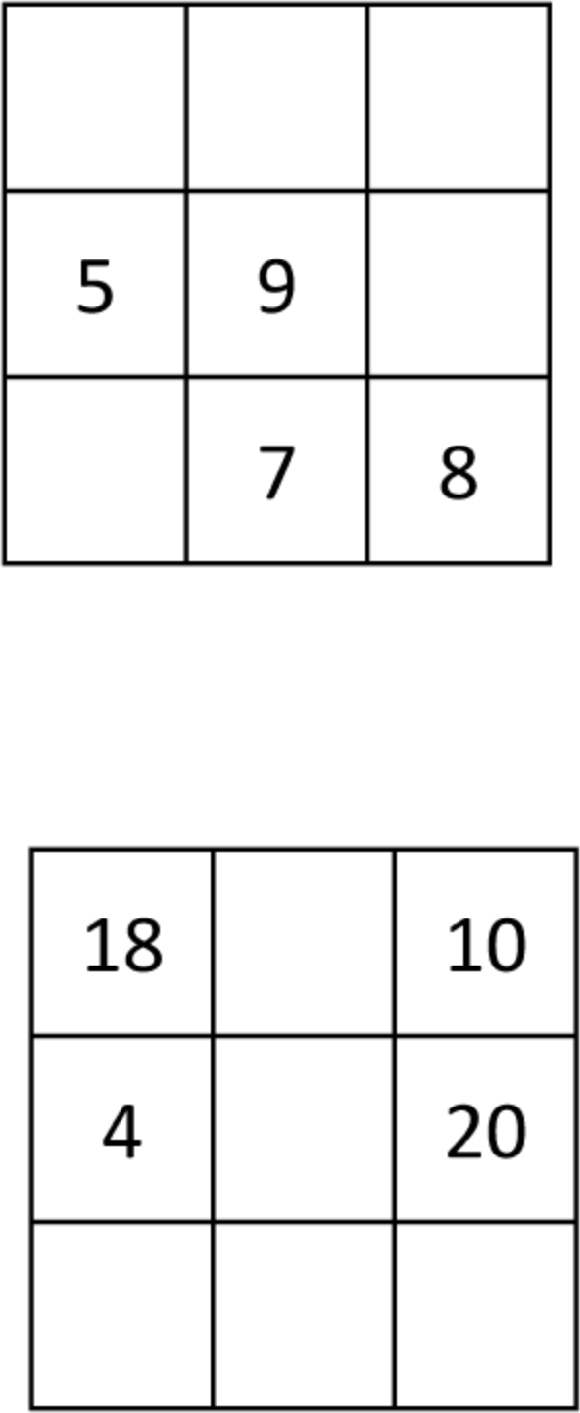In this yellow magic square, the sum is 36. That means each row, column and diagonal all add up to make 36.

**Narrative Writing Activity: Friday, May 22**

**MY SPORT**

**Today's theme: My favourite sport to play or watch**

We want your poems -- long, short, exciting, sad, fun, scary, unbelievable, thrilling ... so we can share them with all our TPP readers. This week's challenge is to compose (write) a poem (any type) about your family. You have acrostic, alphabet, haiku, limerick, sonnet, cinquain or free verse to choose from.

Sometimes, creating rhyming pairs related to the topic can help. Here are some that may help.

**SPORT REPORT**

**PLAY DAY**

**EXERCISE ENERGISE**

**TEAM KEEN**

**TRAINING GAINING**



**Vocabulary Activity: Friday, May 22**

**WORD WORKOUT**

This activity challenges you to find words throughout the magazine that match the definitions provided. The clues give you the page number, a description of the word , the first letter and the number of letters in the word. Sure, we nearly have it done *for* you! :)

**LOCATION, Article/Paragraph CLUE (number of letters, first letter)**

* 1. P15 Mountains and … Having a rough, uneven surface (6,r)
  2. P15 Cities and Towns Repaired and put back into use. (8,r)
  3. P18 My Habitat Difficult to believe. (10,i)
  4. P18 My Appearance Thin plates that cover the bodies of fish. (6,s)
  5. P18 My Babies Animals that kill and eat other animals. (9,p)
  6. P19 Construction People forced to work without pay. (6,s)
  7. P19 … Washington Choose or pick. (6,s)
  8. P12 Caring for … People who cut, prepare, and build with stone. (10,s)

## ANSWERS

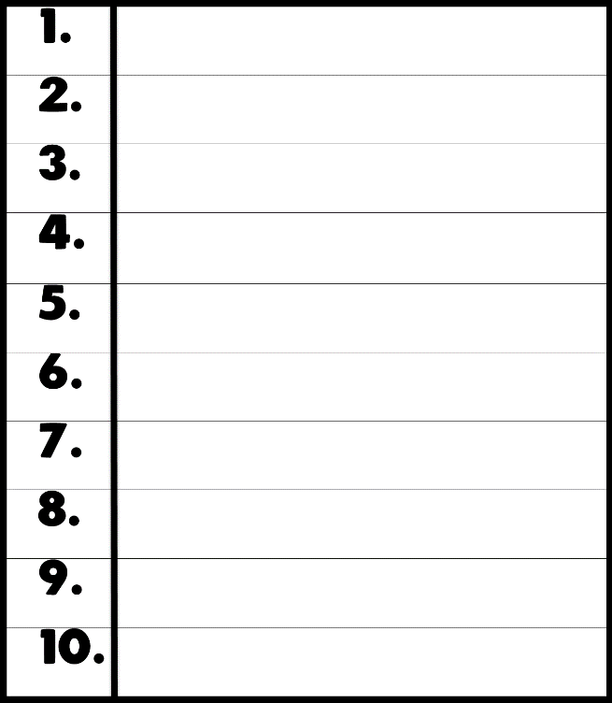

**Daily Maths Activity -- Friday, May 22**

**MAGIC SQUARES**

What is a Magic Square?

In a Magic Square, every row, column and diagonal all add up to make the same total.

In this yellow magic square, the sum is 12. That means each row, column and diagonal all add up to make 12.

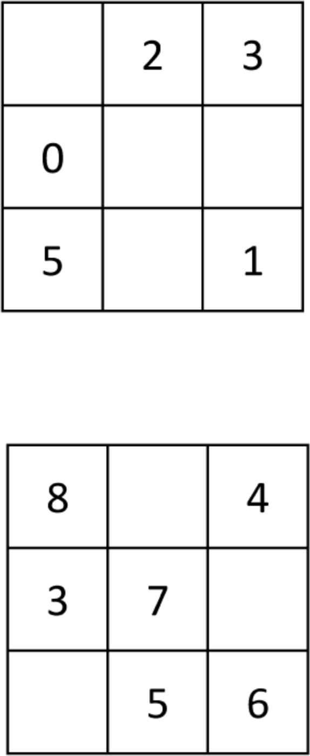In this yellow magic square, the sum is 21. That means each row, column and diagonal all add up to make 21.