# THE PRIMARY PLANET

**PUPIL PACK MAY 18-22**

**TIMETABLE FOR THE WEEK**

**\*\*\***

**WORKSHEETS FOR THE WEEK**

**\*\*\***

**THIS WEEK’S ACTIVITIES**

|  |  |  |  |  |
| --- | --- | --- | --- | --- |
| **MONDAY** | **TUESDAY** | **WEDNESDAY** | **THURSDAY** | **FRIDAY** |
| **MENTAL MATHS CHALLENGE** | **MENTAL MATHS CHALLENGE** | **MENTAL MATHS CHALLENGE** | **MENTAL MATHS CHALLENGE** | **MENTAL MATHS CHALLENGE** |
| **DAILY QUIZ** | **DAILY QUIZ** | **DAILY QUIZ** | **DAILY QUIZ** | **DAILY QUIZ** |
| **FUTOSHIKI PUZZLE** | **FUTOSHIKI PUZZLE** | **FUTOSHIKI PUZZLE** | **FUTOSHIKI PUZZLE** | **FUTOSHIKI PUZZLE** |
| **WORLD**  **MUSEUM DAY** | **PARAGRAPH PROJECT** | **HAVE YOUR SAY** | **COOKING CHAOS** | **POETRY:**  **MY PET** |
| **32-QUIZ PART II** | **EDIT THE EDITOR** | **CLOZE TEST TIME** | **MATHS STORY PART III** | **VOCABULARY CONSTABULARY** |

## Answer Sheet for your daily

**MENTAL MATHS**

**15 mental maths questions read aloud. You write down the answers as quickly (and correctly) as you can! If we are going too fast for you, just play it again, and again, until you get all completed. We'll reveal the answers tomorrow, before we begin the next one. Ready? Let's go!**

**NAME:**

**DATE:**



**Answer Sheet for your daily**

**JUST-2-MINUTES QUIZ**

**Right, before anyone asks you to do anything, be ready to shout: IN TWO MINUTES!**

**As that's how long it will take you to complete this, we're thinking.**

**OK, enough of the intro, we want answers ... NOW!**

**NAME:**

**DATE:**



**Report Writing Activity: Monday, May 18**



**MUSEUM TOURS**

This week's writing activity invites you to choose from a list of famous museums around the world (featured in this month’s Primary Planet feature) and write a report on one. This information text will be used to profile the museum so must contain key and useful information. Here are some guidelines on what report writing involves:

#### Reports are written to describe or classify the way things are or seem to be.

*They organise and record information.*

*Reports are often organised by classification, description and summarising comments.*

*The features of report writing are almost always written in present tense and use specific vocabulary such as the key words below.*

**ARTEFACTS EXHIBITION DISPLAY HISTORICAL ANCIENT**

Head to pages 23-26 in this month’s Primary Planet to choose the museum for your report.



**Comprehension Activity: Monday, May 18**

**32-QUIZ (PART III)**

Pens out, guys! This month's 32-quiz is based on the 32 pages of TPP's May issue. E.g. The answer to Q.23 can be found on page 23.

This week, Part I features the pages 21-30.

1. What do the letters HAS stand for?
2. Which brand of mouthwash is made by Johnson & Johnson?
3. What did Vincenzo Peruggia steal in 1911?
4. The city of Saint Petersburg is in which country?
5. The ceiling of which chapel was painted by Michelangelo?
6. The Elgin Marbles originally came from which country?
7. What does the Irish word ‘dobharchú’ mean?
8. What is the first word in ‘Crack the Quote’?
9. What is the solution to 9 Down?
10. What is Danny Johnson’s nickname?

**ANSWERS**

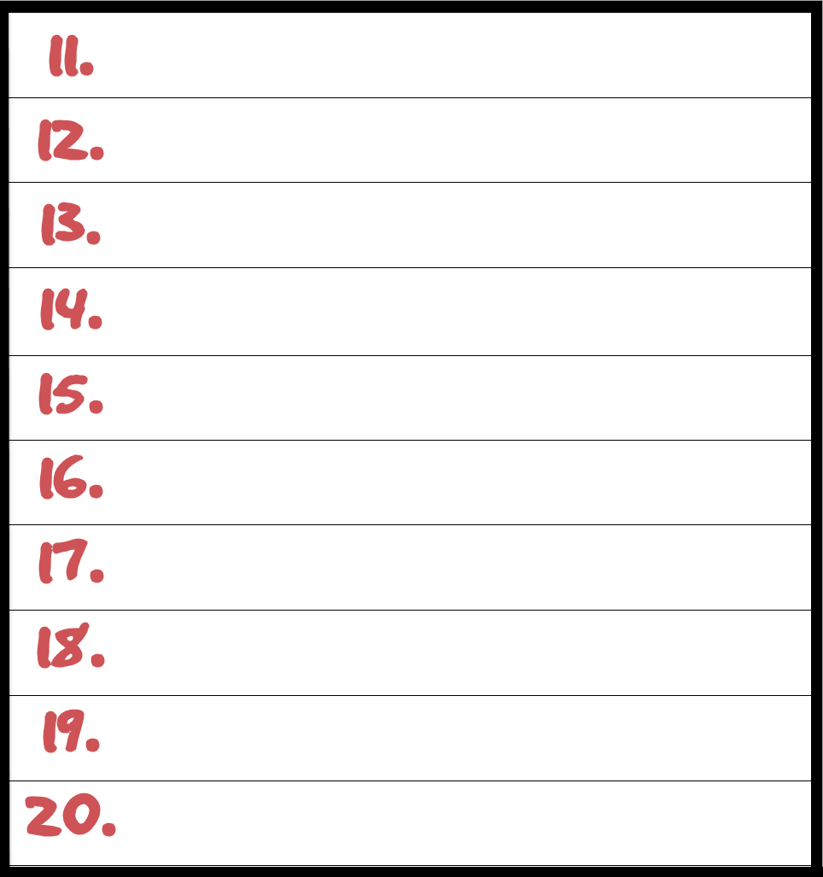

Don't forget, you can also enter your answers online, in the comment box provided.

## Daily Maths Activity: Monday, May 18

**FUTOSHIKI TIME!**

**To solve a Futoshiki Puzzle you must fill in the numbers (1 – 4 for a four-line grid).**

**Make sure that a number appears only once on each column and row. The symbols < and > tell you if the number in each square is bigger or smaller than the number next to it.**

### BEGINNER

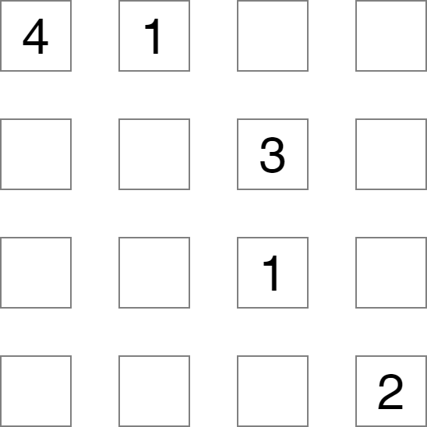

NOVICE

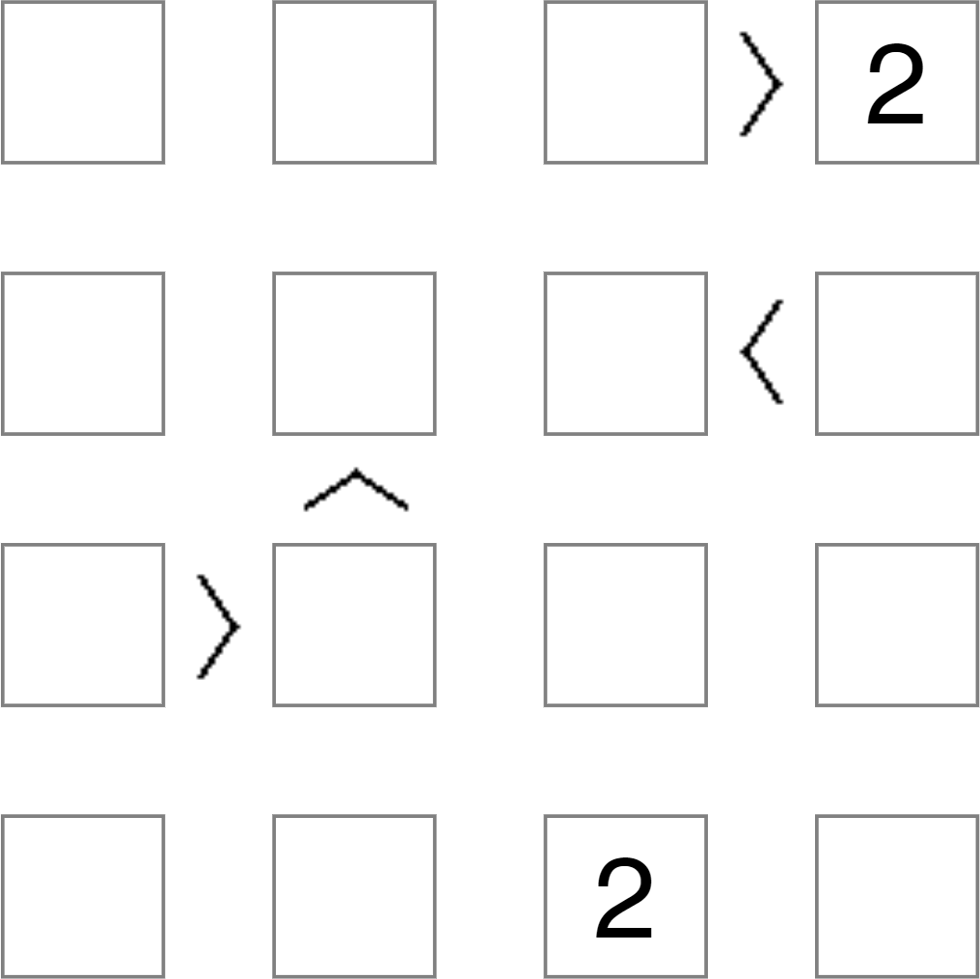

**Narrative Writing Activity: Tuesday, May 19**



**PARAGRAPH PROJECT**

Here, we give you a sentence to begin your creative paragraph with. All you need to do is take it from there. But don't go too mad -- it's a paragraph, not a novel. The trick is, you try to make it as exciting, sad, happy, scary or interesting as you can. Let's get writing!

**Today's opening sentence:**

**Why was it that every time I said one thing, he did the opposite? My patience was wearing thin … very thin!**

**Grammar Activity: Tuesday, May 19**

**EDIT THE EDITOR**

**This grammar activity is based on an article from an issue of The Primary Planet on William Dargan. Read through the article and see if you can spot the 10 spelling mistakes, the 5 missing capital letters and the 5 missing full stops.**

**A Life That Spanned Three Centuries**

In 2016, the story of Emma Moreno made the news all over the world The sprightly 117-year-old italian was born in 1899, making her the only remaining person in the world to have been born in the 1800s. Quiet an achievement, but spaning three centuries is not unique. in fact, in 1799 – 100 years before Mrs Moreno came into the world and the same year that George Washington died – a young girl, christened Margaret Flynn, was born in Dublin City

Having growing up in the early 1800s, Margaret witnessed huge change and conflict around her The Penal Laws ensured she got little edacation, while a man by the name of Daniel O’Connell was begining his fight for Catholic Emancipation when Margaret was in her early twenties.

when Margaret reached adulthod, she married John – a prison offiser in Mountjoy Gaol. before long, Ireland was in the grip of the Great Famine.

Having survived that, Margaret saw even more life-changing events take place – the abalition of slavery in America being one, the move from steam power to electricity being another and, closer to home, Ireland’s strugle for Home Rule, spearheaded by the great charles Stuart Parnell.

By the time Margaret ventured into her third century, aged 101, the Ireland that she had grown up in had almost completely disapeared On the horizon lay a New Ireland that would continue to suffer greatly long after Margaret’s passing in 1911, aged 112.

When the body of Margaret was laid in an unmarked grave on January 12, 1911, she became the oldest person to be buried in Glasnevin Cemetery and, to this day, remains so

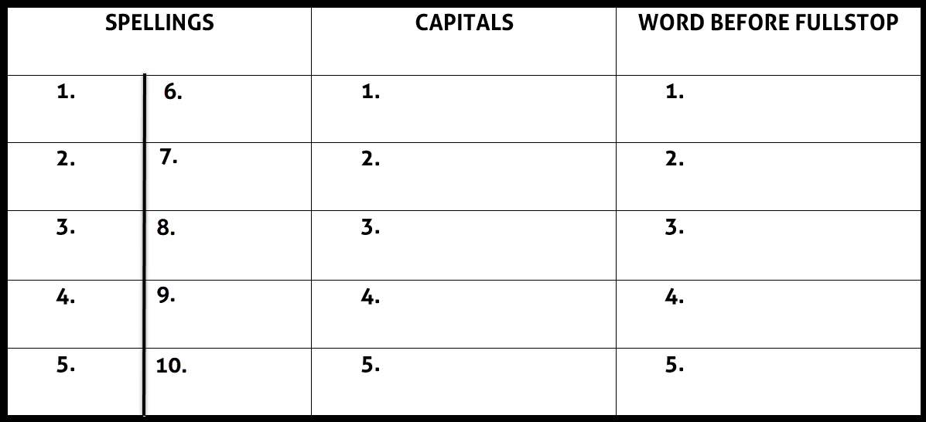

## Daily Maths Activity: Tuesday, May 19

**FUTOSHIKI TIME!**

**To solve a Futoshiki Puzzle you must fill in the numbers (1 – 4 for a four-line grid).**

**Make sure that a number appears only once on each column and row. The symbols < and > tell you if the number in each square is bigger or smaller than the number next to it.**

### BEGINNER

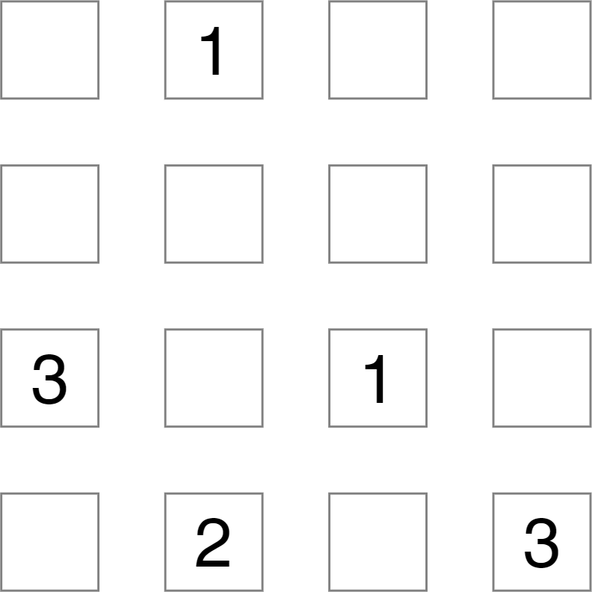

NOVICE



**Persuasive Writing Activity: Wednesday, May 20**



**HAVE YOUR SAY**

In Have Your Say this week, we want you to think about and write about this:

**ALL RULES SHOULD GO OUT THE WINDOW WHEN IT COMES TO FINDING A VACCINE TO COVID-19**

Remember, when you are putting forward your opinion, or partaking in a discussion or debate, make sure you know your facts and be clear in how you feel about a certain topic and why.

## Cloze Test Activity: Wednesday, May 20

**COUNTY FACT-IVITY**

**Each week we present a county of Ireland in all its facts and glory. The only trouble is, 10 words are needed to complete the piece. Have a careful read and see if you can figure out the missing words to complete the facts. When you do, fill in the blanks below or list them 1-10 in the online comment box provided. We'll reveal the correct answers next week!**

**KERRY**

**helping tourist coast sheep released farms province oldest friendly attracts**

County Kerry, Contae Chiarraí, is in the Southwest of Ireland, in the (1) of Munster. Kerry is a maritime county bordered by Cork and Limerick, with the Shannon Estuary to the north and the Atlantic Ocean to the west.

It is a mountainous county with wonderful scenery. The Lakes of Killarney, often called ‘Heaven’s reflection’, are world-famous for their beauty. Kerry is Ireland’s premier

(2) destination with over two million visitors each year.

There is something for everyone in ‘The Kingdom’: Breathtaking views, fishing, water sports, golf, hill climbing, music and historic sites. However, one of the county’s greatest assets remains its (3) people.

Agriculture is of major importance in Kerry, with many dairy (4) supplying the major international food processing company, the Kerry Group PLC. There is a large number of

(5) in the county also.

Famous Kerry people include ‘The Liberator’ Daniel O’Connell, explorer Tom Crean, writer Peig Sayers, playwright John B Keane, Sr Stanislaus Kennedy who has devoted her life to

(6) the poor, and poet Brendan Kennelly.

More than 385 million years ago, a large amphibian known as a Tetrapod left its footprints on the shoreline of Valentia Island, off the Kerry (7). The footprints are the

(8) known fossilised footprints in the world and are also the first fossil record of an amphibian animal.

Puck Fair in Killorglin, Ireland’s oldest traditional Festival, has been in existence for over 400 years. It runs from August 10 to 12 and (9) 80,000 visitors annually. A wild mountain goat is crowned ‘King Puck’ and placed in a cage on a high stand for three days as the locals celebrate with markets and entertainment. At the end of the fair, the goat is

(10) back into the wild.

**Daily Maths Activity: Wednesday, May 20**

**FUTOSHIKI TIME!**

**To solve a Futoshiki Puzzle you must fill in the numbers (1 – 4 for a four-line grid).**

**Make sure that a number appears only once on each column and row. The symbols < and > tell you if the number in each square is bigger or smaller than the number next to it.**

BEGINNER

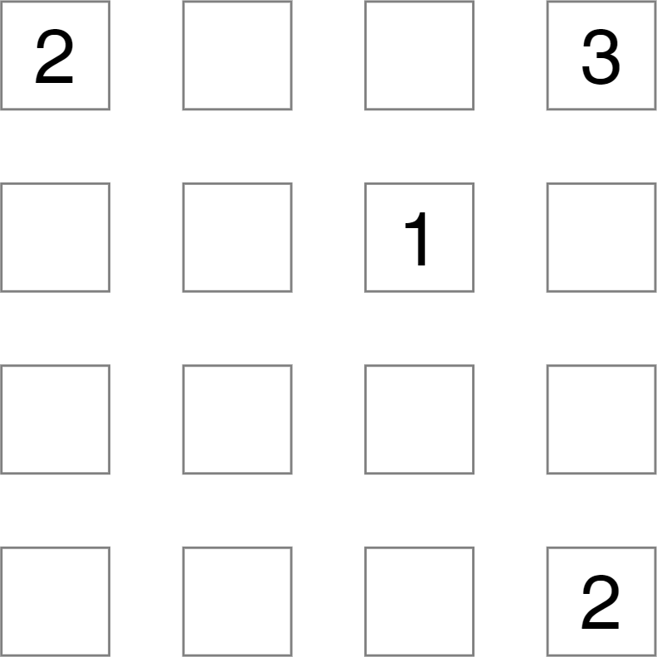

NOVICE

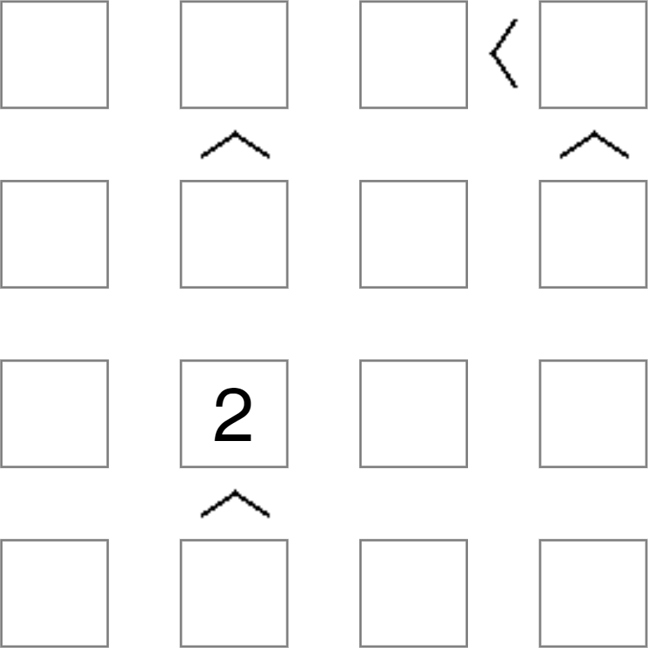

**Procedural Writing Activity: Thursday, May 21**

**COOKING CHAOS**

In this writing activity, we want you to help in the kitchen. You see, our clumsy chef has mixed up the recipe instructions and can't remember where to begin. Can you read through these steps and reorder them by putting numbers 1-10 in the correct boxes, so he can get to work again

and customers can enjoy what they actually ordered! Hurry, doors to the restaurant open in 30 minutes.

Put the milk into a jug and heat in the microwave for 30 seconds. Once warm, add the vanilla extract.

Add the cubes of butter and rub everything together with your fingers until the mix begins to crumb. Now sprinkle the caster sugar into the bowl.

Ask an adult to help you heat the oven to 220oc/gas mark 7.  Using a circle cutter, cut eight scones from the mixture.

Serve with butter, jam and cream

Using a basting brush, brush the top of the scones with the beaten egg and place on the baking tray

Sprinkle some extra flour onto the worktop – this prevents the mixture from sticking to the surface – and pour the contents of the bowl out

Fold the dough over a number of times before patting into a round shape, approximately 4cm deep.

Add this liquid to the large bowl and combine it until smooth.

Bake for 10 minutes or until golden at the top

**Maths Activity: Thursday, May 21**

**MATHS STORY- PART II**

Read this Maths Story -- Tour Time-- and answer the questions below.

# TOUR TIME

Mr Kitt turned on the laptop and began reading out the emails he had received from the two Outdoor Activity Centres regarding the Fifth and Sixth Class tour. They both offered exciting packages.

The first e-mail read out was from Camp Kibanooey. They offered two packages. Package A involved water sports and access to the on-site water slides. This cost twenty-five euro fifty cent per student, but without lunch included. Package B involved the archery and orienteering courses, costing twenty-nine euro each, including lunch.

The second e-mail was from the Noyawn Club. Their primary school packages cost twenty-eight-euro seventy-five cent for Option 1 and twenty-seven euro for Option 2, with lunch included in both. Noyawn Club focused on abseiling and forest trial activities for Option 1, mountaineering and indoor climbing for Option 2.

Mr Kitt decided to let his twenty-eight students in the class have the final say. At the mention of a vote, the kids went wild with excitement. But, after calming them down, Mr Kitt recapped on the different options available to the students so they would know exactly what they were voting for.

When the votes were tallied, Caroline, the school secretary, contacted the bus companies to get the best price she could.

O’Tooles Bus Hire came in the cheapest at three hundred and thirty-six euro for the day, with teachers going free! All the school had to do to secure the booking was pay the standard twelve and a half per cent booking deposit.

Later that morning, while the children were busy with their calculators trying to work out the final cost of the tour per student, Mr Kitt phoned the chosen adventure centre to make the booking. They offered him a deal. If he booked the centre before the fifteenth of May and paid a twenty per cent deposit off the total bill, they would give a five per cent discount on the remaining balance. On hearing this deal, the students urged Mr Kitt to confirm their booking immediately, even though that meant having to work out a new price per student!

When all was done and dusted, Mr Kitt asked if there were any questions.

‘Yes, Seamie?’ asked his teacher. ‘Firstly, is this to do with the school tour and, secondly, is it important enough to have to ask?’

‘Most definitely!’ replied Seamie. ‘Who gets the back seat?’ The class roared with laughter.

**Questions**

1. Camp Kibanooey offered two school tour packages. How much would it have cost in total if the students chose (i) package A (ii) package B?
2. Noyawn Club offered two school tour packages. What would the total difference in price be if the students chose Option 1 over Option 2?
3. What was the difference in price, per child, between the most expensive and the cheapest tour package?
4. How much of a deposit did Caroline have to pay O’Tooles?
5. How much did the bus cost per child?
6. If the bill for the Adventure Centre came to €805 before discount, can you work out which tour package the children decided on?
7. How much of a saving did Mr Kitt make by paying the adventure centre before May 15?
8. On the day of the tour, when Mr Kitt paid the balance due for the bus, he received €6 back in change. How much did he give the bus driver?

## Daily Maths Activity: Thursday, May 21

**FUTOSHIKI TIME!**

**To solve a Futoshiki Puzzle you must fill in the numbers (1 – 4 for a four-line grid).**

**Make sure that a number appears only once on each column and row. The symbols < and > tell you if the number in each square is bigger or smaller than the number next to it.**

### BEGINNER

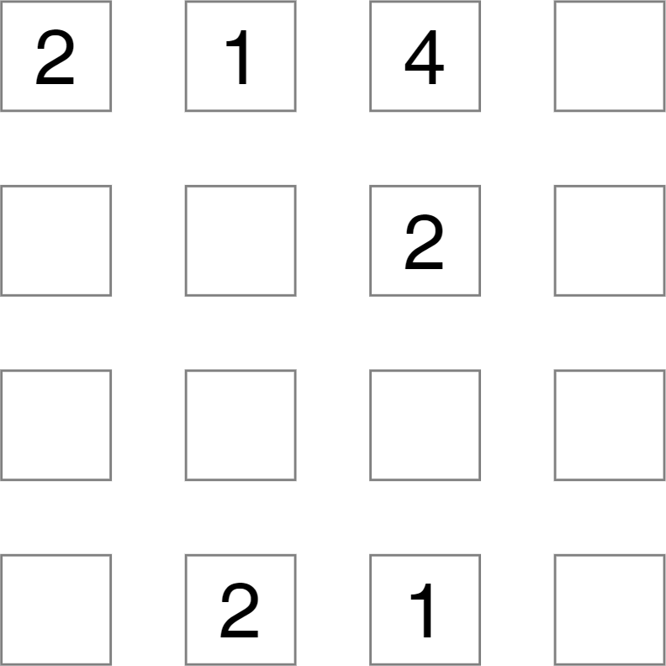

NOVICE

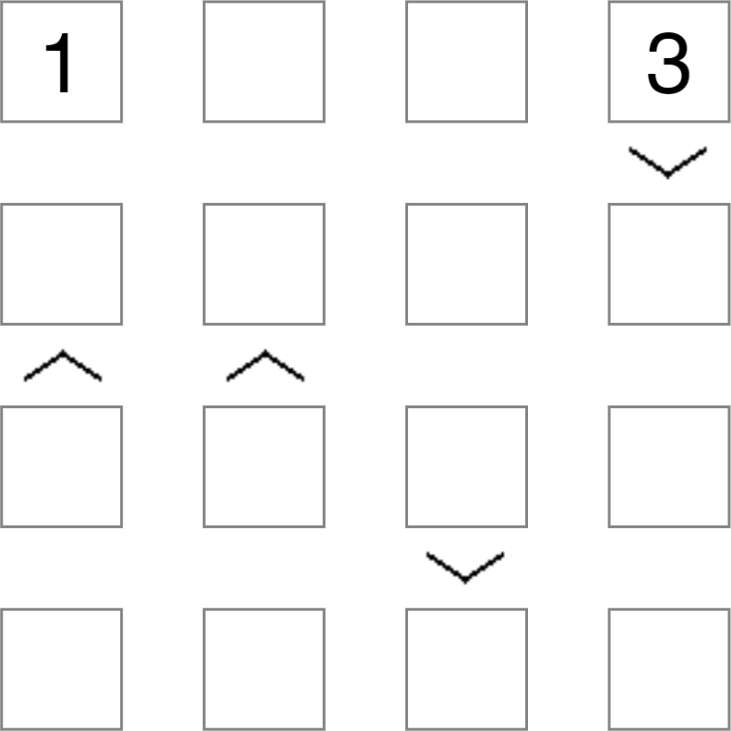

**Narrative Writing Activity: Friday, May 22**

**Today's theme:**

**MY PET**

We want your poems -- long, short, exciting, sad, fun, scary, unbelievable, thrilling ... so we can share them with all our TPP readers. This week's challenge is to compose (write) a poem (any type) about your family. You have acrostic, alphabet, haiku, limerick, sonnet, cinquain or free verse to choose from.

Sometimes, creating rhyming pairs related to the topic can help. Here are some that may help.

**PET MET**

**MOUSE HOUSE**

**HAMSTER GANGSTER**

**GERBIL TERRIBLE**

**DOUBLE TROUBLE**

**CAT FAT**

**RULES FOOLS**

**RUB CUB**

**FRIEND END**

**FEED NEED**

**Vocabulary/Word Enrichment Activity: Friday, May 22**

**VOCABULARY CONSTABULARY**

**Are you a good detective? The Vocabulary Constabulary needs your help.**

You can often detect the meaning of a word or phrase by reading it in context, that is, by reading the other words around it in a piece of text. Find the page, article or paragraph in TPP and then detect the word or phrase that solves the clue to its meaning. The number of letters and the starting letter of the solution are in brackets after each clue.

**LOCATION CLUE (number of letters, first letter) SOLUTION**

* 1. P26 New Museums Modern; belonging to the present. (12,c)
  2. P27 How to Spot … Searching widely for food; hunting. (8,f)
  3. P27 Ava’s Animals having the toes connected by a membrane. (6,w)
  4. P12 Impressionism So precious that its value cannot be determined. (9,p)
  5. P12 Early Life Heartfelt, intense, extreme, very grea.t (6,g)
  6. P21 A World of … Dividing line, border, frontier. (8,b)
  7. P38 Better Late … Craving, longing, yearning, hankering. (6,m)
  8. P39 Robbed … A pause or break in activity. (6,h)
  9. P39 … Six Nations? Consequences, results, effects, outcomes. (13,r)
  10. P40 A Dream Move One of five tendons at the back of the knee. (9,h)

**Now, sort your answers into alphabetical order!**

**Daily Maths Activity: Friday, May 22**

**FUTOSHIKI TIME!**

**To solve a Futoshiki Puzzle you must fill in the numbers (1 – 4 for a four-line grid).**

**Make sure that a number appears only once on each column and row. The symbols < and > tell you if the number in each square is bigger or smaller than the number next to it.**

BEGINNER

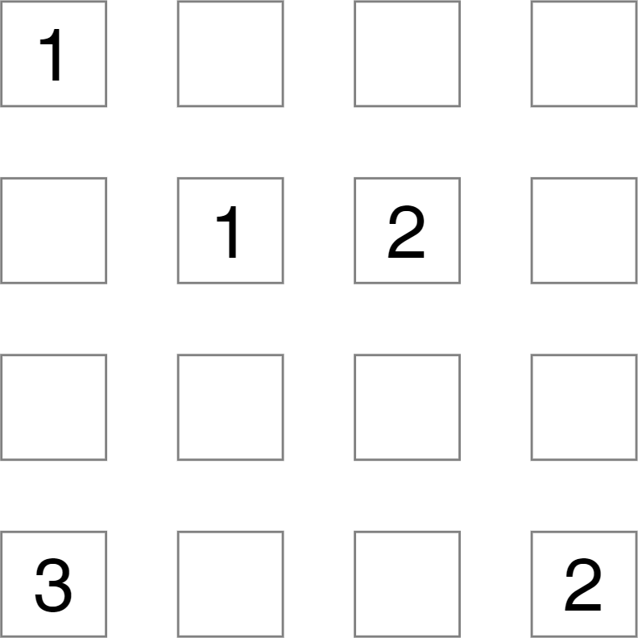

NOVICE

